

version 1.0

16/01/2022

שם הפרויקט

תיאור במשפט של הפרויקט

Project Code: 21220340

Preparing report – FINAL PROJECT 2022

ACADEMIC instractor 1: Ms. Sara tsor

ACADEMIC instractor 2: Ms. yoram segal

presentors

student name 1: 312272230, saar elias

student name 2: 312389083, Naor yekutiely

instractors signiture

תוכן עניינים

1 תקציר 3

1.1 תקציר בעברית 3

1.2 תקציר באנגלית 3

1.3 רשימת מילות מפתח 3

2 טבלאות ומונחים 4

2.1 טבלת שרטוטים 4

2.2 טבלת טבלאות 4

2.3 מילון מושגים 4

3 מבוא 5

3.1 הגדרת הבעיה 5

3.2 האתגר הטכנולוגי 5

4 דרכי פתרון הבעיה 5

5 תוצר מצופה מהפרויקט 5

6 תיאור רעיון דומה שיכול להוות השראה 5

7 סיכונים, אי וודאות ואילוצי הפרויקט 6

8 עבודות בנושא (סקר ספרות) 6

9 מפרט דרישות פונקציונאליות (אין הגדרה לכמות מילים) 6

9.1 דרישות מהפרויקט 6

9.2 אופן תפעול ושימוש בפרויקט 6

9.3 מפרט דרישות חומרה 6

10 מה בוצע עד כה הפרויקט 7

11 תכנון 7

11.1 טבלת אבני דרך 7

11.2 טבלת משימות 7

11.3 גאנט 7

12 מקורות קריאה (זה רק דוגמה) 8

רשימת נספחים 9

נספח א - סכמת בלוקים 10

נספח ב - טבלת אבני דרך ותוצרים (עולה לגוף הדוח) 11

נספח ג - טבלת משימות (עולה לגוף הדוח) 12

נספח ד - גאנט 13

# תקציר

## תקציר בעברית

בפרויקט זה אנו מציגים גישה חדשנית בתחום פתרונות התחבורה בערים חכמות ועתידניות. עם הצמיחה המשמעותית של תחומים כגון: רכבים האוטונומיים, רשתות 5G, יכולות עיבוד גבוהות בענן העתיד של תחום התחבורה בתוך ערים חכמות צפוי להשתפר משמעותית. בעיר עתידנית שבה כלל הרכבים הם אוטונומיים לחלוטין ואין שיקול דעת אנושי בהחלטות המתרחשות כחלק מזרימת התנועה, אנו מציגים צורת חשיבה חדשה בנוגע לשימוש בתשתיות התחבורה בערים שכאלו. כל חוקי התנועה יהפכו לדיגיטליים והם יהיו דינמיים לחלוטין. שינויים דרמטיים אילו, פותחים דלתות חדשות בנוגע לדרכים לניצול מרבי של תשתיות התנועה וייעול של זרימתן. בפרויקט זה אנו מציגים עיר חכמה שכזו, על ידי מידול שלה לידי סימולטור תנועה שבו חוקי התנועה משתנים באופן דינמי. בנוסף, כחלק מהפרויקט אנו נציג ניתוח של המידע שהסימולציה מייצרת לצד השוואה בין הארכיטקטורה החדשנית הזו, לבין המצב הנוכחי בעזרת טכנולוגיית הצגת וניתוח מידע. במסגרת פרויקט זה אנו לא מכוונים להציג אלגוריתמים של אופטימיזציות תנועה, אלא להשתמש באלגוריתמים קיימים שכאלו על מנת להראות את נכונות הנחת היסוד שלנו. אנו מעודדים אחרים לקחת השראה מהפרויקט ומהרעיון היסודי שלו ולשפר אותו, או לממש את הרעיון של שינוי חוקי תנועה דינמיים בעיר חכמה בצורה שונה לחלוטין. לפרויקט זה, קיים נתבך סביבתי שכן הפרויקט מכוון להפחתת הזיהום הנגרם על ידי פליטות Co2 בערים אורבניות מסביב לעולם.

## summary

In this project we present an innovative approach towards transportation solution in a futuristic smart city. With the rising of new technologies such as Autonomous Vehicles (AV), 5G networks, and cloud computing the future of transportation within smart cities is expected to improve in many factors. In a futuristic smart city, when transportation will be autonomous and no human decision will take part, we present a new way of thinking about transportation and road infrastructure in general. All traffic laws will be digitalized and dynamic. These dramatic changes will open up new ways for optimizing traffic and using the road infrastructure in the most efficient way possible. This project presents an architecture for such futuristic system as well as intuitive examples for how such system can be implemented. The implementation we present in this project is a traffic simulator that utilizes all the benefits of having dynamic traffic laws. The simulator presents a futuristic city where all the vehicles are autonomous and the traffic laws change dynamically. The project also includes data analysis and comparison between this new approach against the current one in an interactive and sophisticated dashboard using data presentation technologies. In this project we do not aim to present a certain optimization technic but rather to show the possibility for such system existence in the future, and encourage others to implement traffic optimization algorithms with this new futuristic approach. Furthermore, this project is eco-friendly as it aims to reduce the carbon footprint within urban cities around the world.

## keywords list

Dynamic traffic laws, Traffic simulator, Smart city, Autonomous vehicle, Python Pygame project, Machine learning, carbon footprint

# טבלאות ומונחים

## טבלת שרטוטים

חובה לצרף טבלת רשימת שרטוטים

## טבלת טבלאות

חובה לצרף טבלת רשימת טבלאות

## Acronym

Dynamic Transport Law System (DTLS)

AV

traffic simulator (TS)

Graph Theory(GT)

machine learning(ML)

operating system(OS)

חובה לצרף מילון מושגים של לפחות 10 מושגים שונים שקשורים לפרויקט. לכל מושג יש לכתוב 10-50 מילים. שימו לב, מושגים אלה ישמשו לבסיס לשיחה על הפרויקט בראיון עבודה. ע"י בחירה נכונה של מילים תוכלו לנתב את ראיון העבודה לאזור הנוחות והידע שלכם.

לדוגמא  
למידה עמוקה (Deep Learning) - תת תחום של למידת מכונה המכיל מגוון אלגוריתמים לביצוע שיערוך של סיווגים ותחזיות. האלגוריתם מבוסס על מודל המכיל שכבות של פרספטרון, המבצעים חישובים ליניאריים ולא ליניאריים. המודל מבצע לימוד עצמי על בסיס אוסף תצפיות (בסיס נתונים) ועל בסיסם מבצע שיערוך.

# introduction

The general field of our project is Smart Cities. The rapid growth of human population, spoilage of natural resources, increasing population and number of vehicles in the urban life around the world are in a desperate need of a modern solution which the existing model of a city has we know it cannot provide. To solve these issues a new city model has been proposes in past several years know as a Smart City [1]. Also called eco-city or sustainable city, the smart city aims to improve the quality of urban services or reduce its costs. In the past few years many governments and cities around the world adopted this approach and implemented it in many different ways. Implementations and actions already taken in the field of smart cities are adequate water supply, assured electricity supply, sanitation, including solid waste management, efficient urban mobility and public transport, affordable housing, robust IT connectivity and digitalization, good governance, sustainable environment, safety and security of citizens and more. Examples for such cities are Singapore, Barcelona, San Francisco, London and more. Building a smart city or transforming a city into one is no easy task, and there are many challenges to take into account. Infrastructure and costs, security and privacy concerns and social risks are a partial list of the challenges in building a smart city. Despite these challenges a smart city has many practical, economic benefits such as environment impact, optimization of energy and water management, transportation, security and many more.

## defining the problem

In the past decade traffic congestions has become an inescapable condition in large and growing metropolitan areas across the world [2]. Traffic congestions are getting worst with the growth of human population and increasing ratio of human–vehicle. The current traffic architecture and systems cannot handle the number of vehicles on the road and a new solution for inner city transportation is required.

## The technological CHALLENGE

There are couple of reasons that a system such as DTLS has not yet been invented, The DTLS is a futuristic system that cannot be implemented without some core futuristic dependencies such as all vehicles will be fully automated with no exceptions, wide spread of 5G networks all around the city, social and government conception and more. No such city exists yet and, in this project, we will simulate such futuristic city. The growth of AV industry, 5G networks, cloud computing and efficient hardware technologies enables the DTLS possible existence. Assuming the DTLS exists, up and running in a smart city, transport congestions will be nearly eliminated within this city. The reason is that DTLS can make such a difference is a new innovative way of thinking about road infrastructures. Imagine a major highway leading in and out of the city on a Monday morning, one side of the road for entering the city is highly conject and the other way is almost completely empty as shown in Figure 1. It is clear that this is not an optimized way of using road infrastructures. In such situation the DTLS will open both ways in the direction of entering the city and use alternative ways for leaving the city.

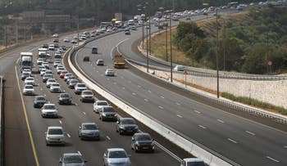

Figure 1: ONE WAY TRAFFIC CONGESTION

# Ways to solve the problem

Solution 1 (Preferred):

Our primary objective is to solve the problem by creating a traffic simulator(TS) that will simulate dynamic traffic laws in representative area such as Manhattan New-York. The implementation is based on an existing TS which we will extend and change according to our needs. Such TS can be found in the article: [3]. The core data structure of the code will be based on Graph Theory(GT) [4] where every node will be represented by a vertex and every road will be represented by an edge in the graph. The TS will have two main functionality modes:

1. TS under static traffic laws.

When using static traffic laws TS, the simulation will simulate the current way that traffic infrastructure is used as for today.

1. TS under dynamic traffic laws.

When using dynamic traffic laws TS, the simulation will simulate the result of the implementation of DTLS.

When executing the main function both modes will run in parallel. The simulation will show both runs side by side while collecting and presenting throughput and data about the simulation. The program architecture will be based on containerized environment. Each TS will be in his own container, another container with a database and one more container with Grafana. All the containers will share the same network and communicate with each other.

Solution 2:

This solution consists of two major parts:

1. Two AVs:
   1. Hardware: The vehicles are equipped with Arduino-based self-driving systems, as well as Jetson-based case and response systems. The Arduino will control driving related hardware such as motors. And the Jetson will control all the machine learning(ML) related hardware such as camera, Lidar, etc.
   2. Software: The Arduino micro-controller will be loaded with routine software to control all the hardware related to driving. This software will be written in C language using the Arduino IDE. The Jetson nano will be loaded with Ubuntu OS which will run the ML related software using Python language and additional ML frameworks such as TensorFlow. In addition, the Jetson nano will hold the current map and traffic laws and feed them to the Arduino. The Jetson will communicate with the main server using WIFI sending data about congestions and obstacles and receiving updated map and traffic laws from the server. whenever a new map or laws update is received by the Jetson it will pass it on to the Arduino.
2. DTLS (Dynamic transport law system) software and infrastructure:
   1. Hardware: The main server will be a personal computer with Ubuntu OS. The main server will not require special computing power for this project and thus it can be any personal use computer. The minimal requirements from the server are having WIFI communication abilities.
   2. Software: The DTLS will run on the main server. Receiving data from the vehicles analyzing it and making map and laws decision and sending those decisions in the form of a new updated map and a set of traffic laws. All data transformation will be passed using JSON format.

Our approach for implementing the transportation in a smart city is innovative and futuristic. A smart city transportation using AV provides us with new solutions and opportunities [5]

# expected project artifact

In the end, we expect to show the ability of creating dynamic traffic law system in a smart city by presetting a number of real-life situations where the DTLS can be evolutionary. We will present three screens, two of them will present the TS in real time. One screen with TS without dynamic traffic laws, and the other one with dynamic traffic laws enable. Both simulations will use the same probability inputs to preserve the data integrity. Each screen will present different behavior although the inputs are the same. The third screen will present a Grafana dashboard that was enriched with data from the simulations. The dashboard will present the throughput and more matrices differences between the simulations.

# Describing a similar idea that can be inspiring

Every Monday morning while driving to work in Tel-Aviv, we have a lot of free time for thinking while almost standing still in traffic jams on Ayalon high-way. Every time we look to the other side of the road leading outwards from the city, an uneasy feeling is passed throw our body when seeing it almost completely empty. One morning we understood why. Seeing such inefficient and waste of road infrastructure, suddenly didn’t make sense. These thoughts with the combination of prior knowledge of the concept of smart cities led us to this idea.

# Risks, uncertainty and project constraints

This project requires integration of many different technologies. As a result there are many risks involved as follows:

1. Integration of different technologies:

Risk: The project includes many different technologies such as Python scripting language, Docker, Docker Compose, Grafana, Database and more. Thus, the task of integrating all the different technologies in an efficient and coherent manner requires a big amount of effort.

Possible solution: The current architecture can be changed at any given time. All of the source code is written with source control technology(Git), this allows us to build the project in many different branches in parallel without having one solution interfering with the other.

1. Innovative approach:

Risk: We present a new and innovative way of optimizing the usage of road infrastructure in a manner that has never been suggested before. This innovative project presents us with many unpredictable issues and unexpected obstacle as we go.

Possible Solution: Both of us are currently working in development teams in an agile environment. In this project we work according to agile software development methodologies, this allows us to react fast to changes in a dynamic project like this. Furthermore, we rely on many different aspects that we learned during our studies such as Data-structures, Algorithms, Software Engineering, Physics, Calculus and all the different coding language we have learned.

1. Constrains:

Fixed map area for the simulation: In this project our main goal is to show the correctness of DTLS. Thus, showing the correctness in a representing area such as Manhattan New-York satisfies our needs. The reason we do not allow a dynamic choice of map area is only because of the big effort it requires without serving our goal directly. Note – We build our code in a way that it is extendable and such feature could be merged in future version of the projects.

# similar works in the field

1. Simulating Traffic Flow in Python: This practical article presents an efficient and relatively simple TS written in Python scripting language. Alongside all the theoretical aspects of developing a TS, the author published the entire source code as an open-source Git repository. Thus, this project is a great starting point for us to extend from. [3] The main reason behind simulating traffic is generating data without the real world. Instead of testing new ideas on how to manage traffic systems in the real world or collect data using sensors, you can use a model run on software to predict traffic flow. There are three main possibilities When implementing a TS:

* Microscopic models - represent every vehicle separately and attempt to replicate driver behavior.
* Macroscopic models: describe the movement of vehicles as a whole in terms of traffic density (vehicle per km) and traffic flow (vehicles per minute). They are usually analogous to fluid flow.
* Mesoscopic models: are hybrid models that combine the features of both microscopic and macroscopic models; They model flow as “packets” of vehicles.

In our project as well as in this TS, the Microscopic model was chosen

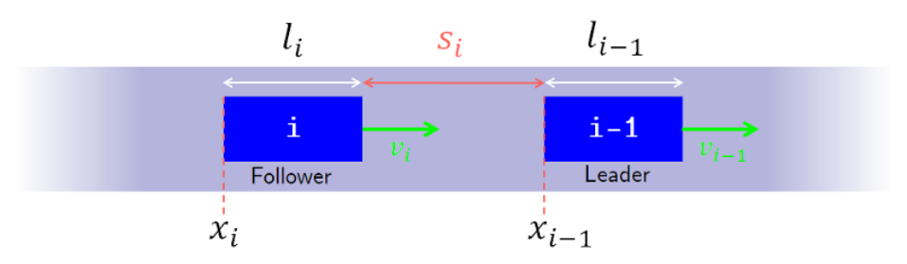

Figure 2: the microscopic ts model approach

. In the figure above we present how the basic concept of the model can be implemented when:

$x_{i}$– The i’th vehicle.

$l_{i}$– The length of the i’th vehicle.

$v_{i}$– The velocity of the i’th vehicle.

$s_{i}$– The distance between the $i$ and the $i-1$ vehicle.

And from the above we can drive:

$s_{i}=x_{i}-x_{i-1}-l_{i}$, $Δv=|v_{i}-v_{i-1}|$

1. The Development of the Smart Cities in the Connected and Autonomous Vehicles (CAVs) Era: From Mobility Patterns to Scaling in Cities: A smart city transportation network needs to be clean and efficient. The main goal is Reducing traffic congestion inside the city as well as Reducing the CO2 footprint. In order to provide a city with Intelligent transportation there is a need of many sensors and traffic management centers. Technologies that are currently being developed in the area of AV are crucial part of transforming a city into a Smart City [6].
2. Understanding autonomous vehicles: One of the key aspects of A smart city is transportation. Due to investment in and development of road infrastructure and vehicle technology, AV are expected to be the next big breakthrough. In the future, drivers will not be required to drive their vehicles, but instead the vehicle will be supplied with the destination's address, and the vehicles will begin to travel the required route using traffic laws visible on the road and connectivity to the Internet [7].

# Functional requirements

## Project requirements

The system shall run the simulations according to the generated inputs. The system should be able to calculate and analyze the data in real time as well as deep data analysis after execution. The system should be able to handle parallel executions up to 60 frames per second.

## project operation and usage

The programs main window shall have three main functionalities as shown in figure 3.

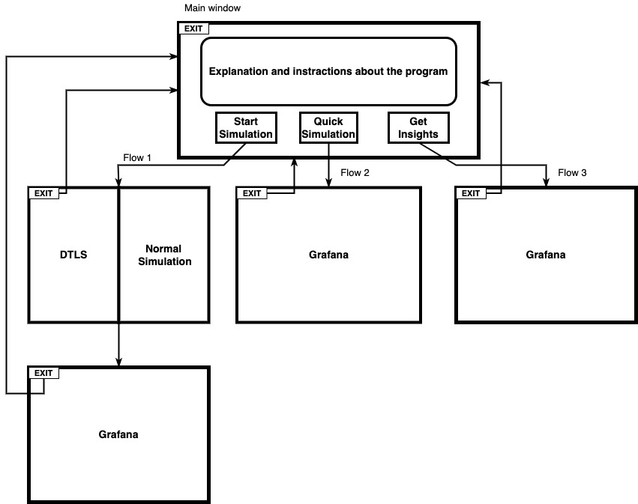

Figure 3: system implementation

The main window will present a short explanation about the projects goal and implementation as well as short instructions regarding how to use the program. A quick link to the programs documentation will be added as well. Below, there will be three buttons:

1. Start simulation(flow 1 in figure 3): When clicking on “Start simulation” the user will be redirected to a new window split to two. Both sides shall present a simulation in real time while showing dynamic metrices. One side with DTLS, and the other side with normal TS. After both simulations end, a Grafana window will be presented with insights about the simulations.
2. Quick simulation(flow 2 in figure 3): When clicking on “Quick simulation” a quick simulation will start in the background. This option is used for getting quick insights in short time. After the background simulation finishes a Grafana window will be presented with insights about the simulations.
3. Get insights(flow 3 in figure 3): ): When clicking on “Get insights” a interactive Grafana dashboard will be presented. The dashboard will have the ability to present data with queries from past simulations, Thus the dashboard will be able to present data from a single simulation or from a combination of many simulations, or even all time.

## system requirements

The program inherits the Pygame python library and thus it also inherits the library minimum system requirements which are:

* OS: 64-bit Windows 7 or later or OS X 10.11 or later.
* Processor: 1.5GHz or faster.
* Memory: 4GB (4,096MB) RAM.
* Free HDD space: 3GB.
* Monitor, mouse and keyboard.

Software requirements:

* Docker.

# מה בוצע עד כה הפרויקט

At the beginning, the project was to build a simple AV based on Jetson Nano with the following goals: detecting objects, autonomous driving to target point, detecting pedestrians. After the two meetings with our instructor we felt the project is not sophisticated or interesting enough in our opinion. So, we asked the collage management for the permission to redefine the project to a new one which is more complicated and challenging. After a short while, we received the green light and presented our new idea for the project. The new idea was to create a system with AVs where the traffic laws changed dynamically and the AVs act accordingly to the dynamic set of laws.

After the redefinition of the project we started working on possible implementations. The selected implementation was using two AVs each one is comprised of a Jetson Nano, Arduino, Lidar sensors and a camera. Alongside the AVs there will be a main server with all the software related to managing the dynamic traffic and sending the data back and forth to the AVs. The first task we had is learning about the Jetson Nano and ML. As for ML, we took a practical course led by our instructor. To learn about the Jetson Nano, we took a Jetson Nano from the collage logistic department and took an online course for learning about it. As part of the course, we needed to install an operating system(OS) and we encountered an issue with burning the OS on the memory card we received. After reading the minimum requirements we saw the memory card wasn’t subtle and we asked for a new one from the logistic department. After the card replacement we managed to burn the OS on the card and started working with the Jetson Nano.

Following the work we have done on the Jetson Nano, we got to the understanding that the implementation we have choose does not serve the goal we are trying to accomplish in a complete manner. The reason is that using only two AVs, is very limiting and does not produce enough data in order to present the correctness of the basic assumption we have made. Which is using the DTLS leads to maximum utilization of the road infrastructure. After these insights, with the collaboration of our instructor, we came up with a new and improved implementation which is converting the project to pure software solution which is a TS.

Moving to a software solution allows us to produce an exponentially larger sets of use cases, which represent the real life in much better precision. Furthermore, the DTLS is a complex system which includes hardware and software aspects. The hardware related to the core functionality of the DTLS is having fully automated AVs, which are integrated to work with the DTLS software interface. In this implementation we implement the software aspect of the system, without the effort of the hardware aspect. This enable us to focus on the logical aspects of the system and hence get optimal results according to the time invested in the project.

After the realization that we need a TS, we started thinking about different technologies and software languages, that we are going to use in order to build the simulator. It was clear to us from our research an prior knowledge that we are going to use Python scripting language. There are two main reasons why we choose Python, the first one is the rich set of different libraries such as gamming and GT. The second one is the simplicity of the language. At the starting point with the guidance of our instructor we got to realization that there are two ways to proceed. The first one is writing the simulator from scratch and the other one is finding an existing open-source simulator that we can extend to our needs. Following a long research we have found an open-source TS written in Python with full documentation which was a great starting point for our project. The documentation includes a detailed and straightforward article about the simulator [3]. We presented this simulator to our instructor and he approved. The chosen simulator uses Pygame library as the main framework for the simulation. The simulator dynamically creates the traffic infrastructure(roads, intersections, headlights, etc...) and populate it with vehicles according to probability parameters in the simulation.

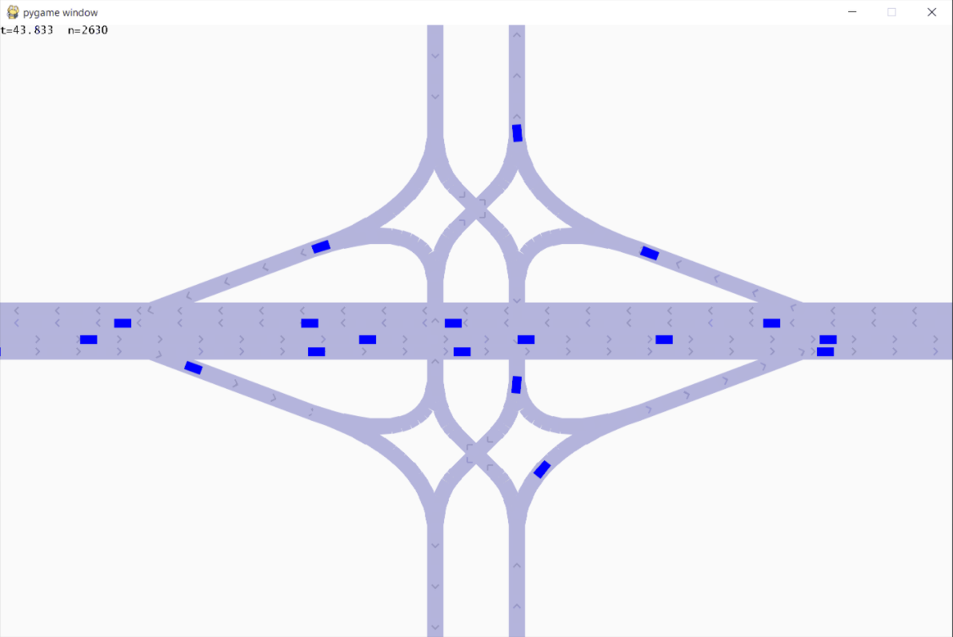

Figure 4: example of the base simulator

As shows in figure 4, in the simulator each road has a direction according to the arrows, and a vehicle is represented by a blue rectangle.

Initially we started from reading the article carefully and understanding all the theoretical aspects of the simulator. Only after we fully understood all the theoretical aspects, we started learning the code. The code is written in Object Oriented Programming(OOP) concept. The core classes of the program are:

* + - Window class – This class uses the Pygame library and controls all the UI aspects of the simulation.
    - Vehicle class – This class represent a single vehicle in the simulation.
    - Vehicle Generator class – This class generates vehicles using the vehicle class according to probability inputs.
    - Road class – This class represent a single road in the simulation holding zero or more vehicles.
    - Simulation class – This class initialize all the different classes and parameters in order to start a simulation and controls the data flows between them.

The existing simulator is not suitable for presenting real life. In order to improve the simulator we added the following features:

* + - Distinct vehicle – The simulator supports only one kind of vehicle. We added the support of three different kinds of vehicles. The distinguish between them is supported in two levels, the first is by different colors and sizes in the UI, and the second is the size and speed of the different vehicles as presented in the memory. The three vehicles representation are:
      * Small – this representation is used for A’ driver license category(as shown in figure 5) and the color we choose for the category is Red(as shown in figure 6).
      * Medium - this representation is used for B’ driver license category(as shown in figure 5) and the color we choose for the category is Green(as shown in figure 6).
      * Large - this representation is used for C’ and D’ driver license category(as shown in figure 5) and the color we choose for the category is Blue(as shown in figure 6).

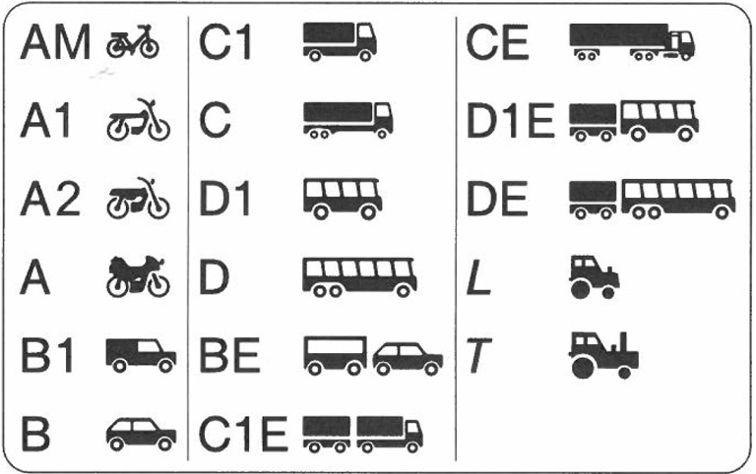

Figure 5: driver license categories

The way we implemented the different speeds for each category and also made each vehicle(even if from the same category) speed different is by defining the average speed and speed range boundaries for each category, and using a random number(can be positive or negative) give each vehicle a random speed value within their allowed range. Mathematically: given an allowed range for category

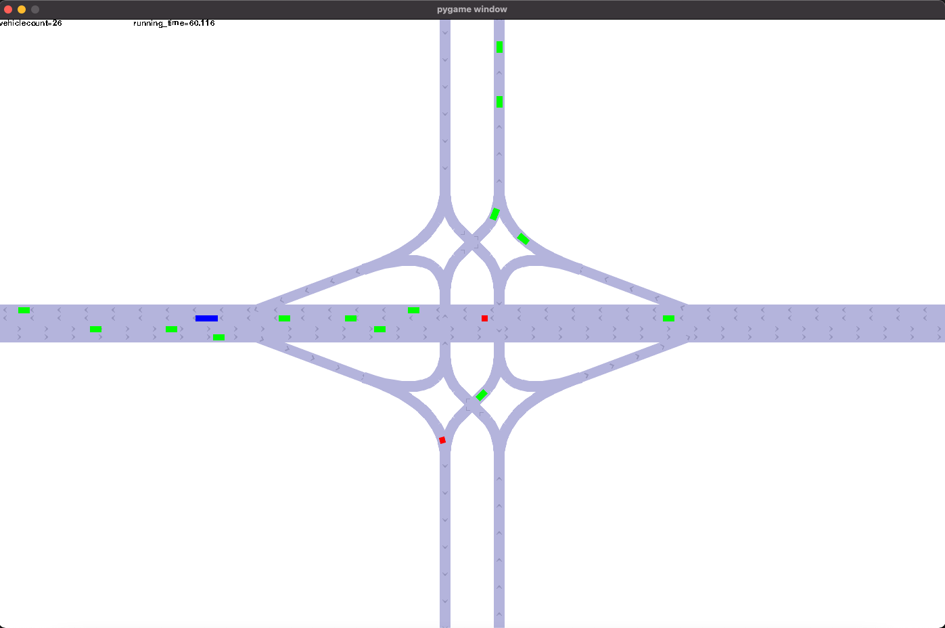

Figure 6: distinct vehicles

As part of data collection we started presenting metrices about the simulation. The metrices can be found on the top left corner of the simulation window(as shown in figure 7). As for now, only two metrices are shown. The first one is the total number of vehicles in the simulation at any given time, and the second metric is the time passed in seconds from the execution time. Many more metrices will be added in the future.

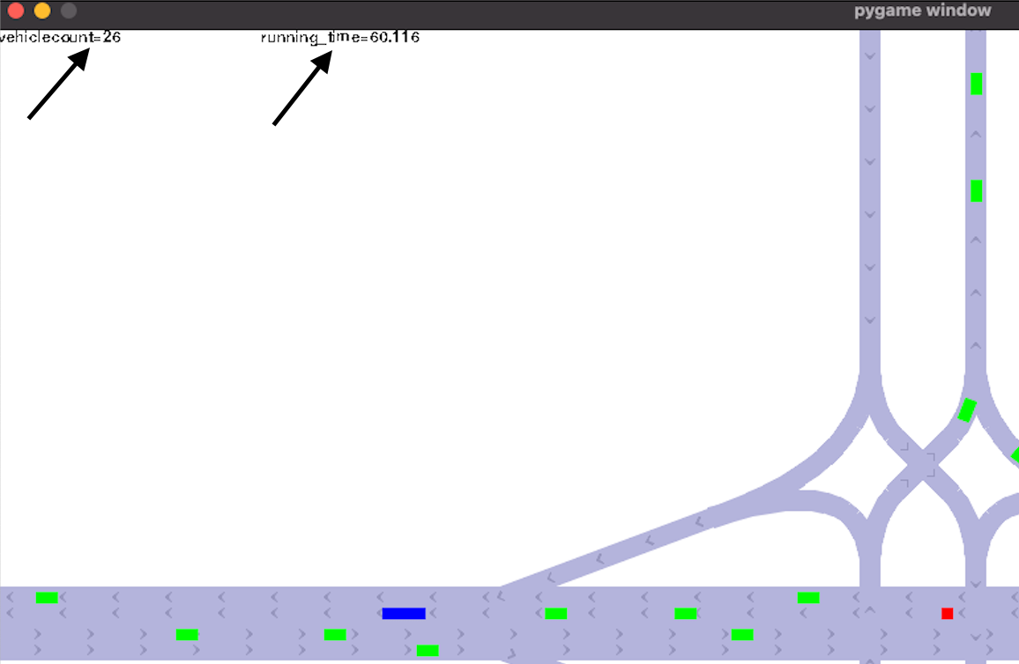

Figure 7: simulation metrices

The next challenge we encountered was creating new simulations including roads, intersections, headlights, etc.. Creating new simulations with the current implementation is exhausting, because of none generic and poor architecture in the simulator. The creation of each element is specified with fixed pixels and that makes building large and complex simulations to nearly impossible. The solution we came up with is adding a customized background photo with X and Y axis to map each pixel in the simulation(as shown in figure 8).

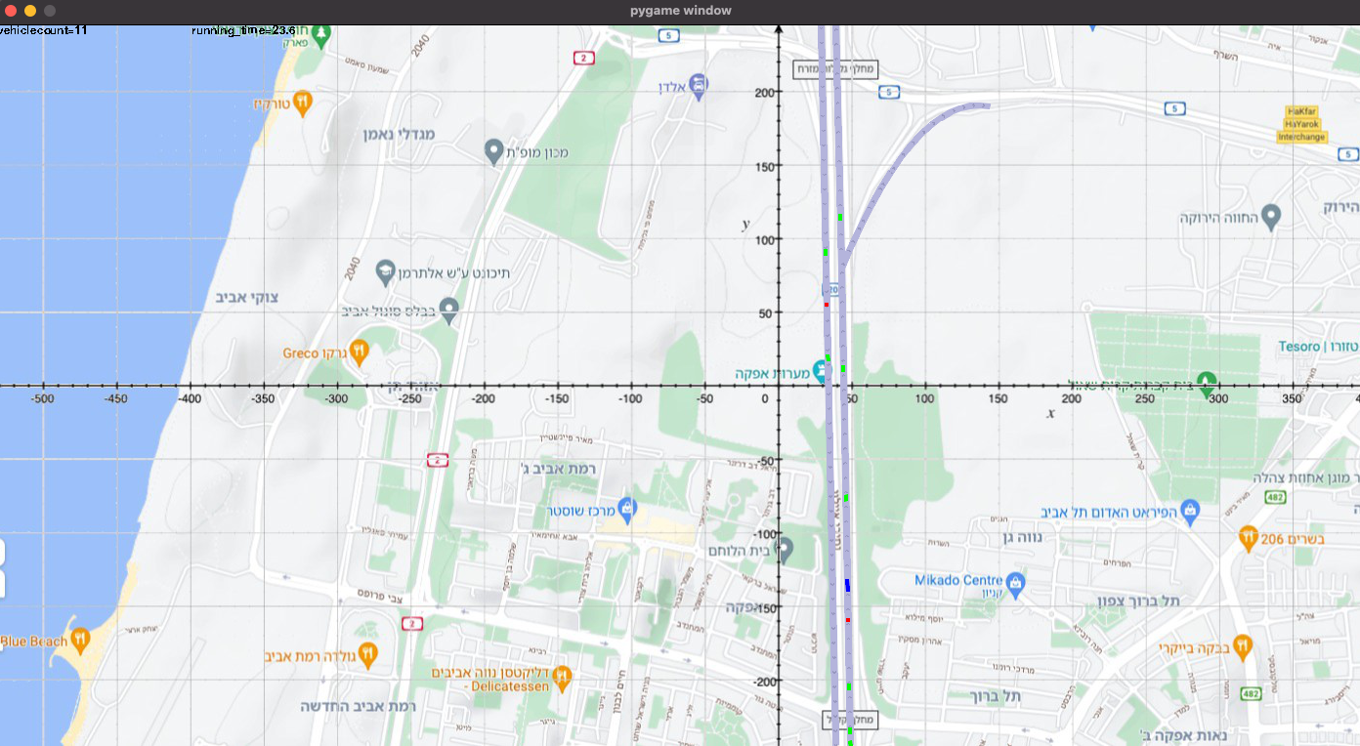

Figure 8: pixelized map

The new feature we are currently working on is modelling the map as a graph. Each intersection will be represented as a vertex and each road as edge in the graph. Modeling the map as a graph allows us to use GT algorithms and hence get better performance and resilience. This feature has a direct impact on all of the programs modules and that makes it a large and complex task. Furthermore, using a graph allows us to make quick changes in a generic way on the map in real time. This is very important for the next and most major phase of the development which is implementing the DTLS from the TS.

פה עליכם לתאר מה עשיתם עד כה בפרויקט. עליכם להציג לפחות תוצר מדיד אחד, כפי שהתחייבתם בטבלת אבני הדרך. תתייחסו לשלבים בטבלת אבני הדרך, וכיצד השלמתם את המשימות והיעדים. יש לתאר אחוזי ביצוע ביחס למתוכנן.

חשוב לצרף צילומי מסך, צילומי חומרה, תמונות ניסויים בשטח, לתאר קוד שכתבתם (אפשר לצרף את הקוד עצמו רק כנספח). מודגש כל תמונה או גרף שאתם מצרפים חייב לקבל הסבר מפורט מה רואים ולמה צרפתם אותו.

יש לתאר את ההישגים שלכם והאכזבות והכישלונות. חשוב לתאר פעולות שביצעתם גם אם לא הובילו לתוצאה רצויה או שהחלטתם לזנוח את הכיוונים האלה. מאד חשוב לשכנע שעשיתם עבודה עד פה. אפשר לתאר את המפגשים עם המנחים.

מומלץ להיעזר בסיכומי הפגישות עם המנחים.

פיסקה זו, היא הפסקה החשובה ביותר בדוח התקדמות. שכן פה אתם צריכים לשכנע את הבודק שהכן התקדמתם והפרויקט שלכם רוקם עור וגידים. נא לא לחסוך במילים ובאמצעי המחשה - כמו גרפים, תמונות, דיאגרמות בלוקים. לא נקבע פה מינימום מילים אך שימו לב, כי תיאור דליל שלא יצליח לשכנע במידת העשייה שלכם, ישפיע על הציון באופן אקוטי.

# תכנון

## טבלת אבני דרך

|  |  |  |  |  |
| --- | --- | --- | --- | --- |
| Artifact | Total man hours | End date | Milestone description | Milestone number |
| Preparing report | 25 | 24/10/2021 | Preparing report | 1 |
| Driving vehicles + running server | 140 | 4/1/2022 | Hardware validation | 2 |
| Progrerss report | 50 | 16/1/2022 | Progrerss report | 3 |
| AVs communicate with the server | 300 | 3/7/2022 | Vehicles and server integration | 4 |
| Poster + presenatation + POC | 60 | 12/7/2022 | Projects day + practical presentation | 5 |
| Completly operative system | 120 | 8/9/2022 | Final ajustments | 6 |
| Project book + working project | 45 | 15/9/2022 | Defanses | 7 |

יש להעתיק ולעדכן מדוח מכין

## טבלת משימות

|  |  |  |  |  |  |  |  |
| --- | --- | --- | --- | --- | --- | --- | --- |
| Tasks Table | | | | | | | |
| Milestone number | Milestone description | Task number | Start date | End date | Total working hours | Responsible | Expected artifact |
|  |  |  |  |  |  |  |  |
|  |  |  |  |  |  |
|  |  |  |  |  |  |
|  |  |  |  |  |  |  |  |
|  |  |  |  |  |  |
|  |  |  |  |  |  |
|  |  |  |  |  |  |  |  |
|  |  |  |  |  |  |
|  |  |  |  |  |  |
|  |  |  |  |  |  |  |  |
|  |  |  |  |  |  |
|  |  |  |  |  |  |
|  |  |  |  |  |  |  |  |
|  |  |  |  |  |  |
|  |  |  |  |  |  |
|  |  |  |  |  |  |  |  |
|  |  |  |  |  |  |
|  |  |  |  |  |  |
|  |  |  |  |  |  |  |  |
|  |  |  |  |  |  |
|  |  |  |  |  |  |

פה עליכם להציג את חלוקת המשימות בין חברי הקבוצה.

כל סעיף בטבלת אבני הדרך הוא פרק.

בכדי להגשים את האבן דרך יש לבצע סידרת משימות.

פה עליכם להכין טבלה ולרשום מספר משימות (לפחות 3 משימות לכל אבן דרך - כלומר 3 שורות בטבלה לכל אבן דרך). כל משימה תקבל מספר סידורי בהתאם למספר אבן הדרך. אם דנים באבן דרך 3. אזי משימה ראשונה תהיה 3.1 והשנייה 3.2 וכן הלאה. בכל משימה עליכם לרשום את העמודות הבאות: מספר סידורי של המשימה, מתי היא מתחילה, מתי היא תסתיים, כמה סה"כ שעות תעבדו על המשימה, מי מבצע את המשימה ומה התוצר בסוף המשימה (סה"כ 6 עמודות).

עליכם לוודא כי סה"כ השעות שאתם כותבים לכל משימות יתאים לסה"כ השעות שכתבתם עבור כל אבן דרך. וצריך לוודא כי סה"כ השעות על כל הפרויקט הוא כ450 שעות לסטודנט.

## גאנט

עליכם לצייר גאנט של הפרויקט

# References

|  |  |
| --- | --- |
| [1] | N. Radovan, K. Radek and K. Jaroslav, "Smart City Concept, Applications and Services," *Journal of Telecommunications,* vol. 3, p. 8, 2014. |
| [2] | A. Downs, "brookings," 1 January 2004. [Online]. Available: https://www.brookings.edu/research/traffic-why-its-getting-worse-what-government-can-do/. [Accessed January 2004]. |
| [3] | B. Himite, “Simulating Traffic Flow in Python,” 5 September 2021. [מקוון]. Available: https://towardsdatascience.com/simulating-traffic-flow-in-python-ee1eab4dd20f. |
| [4] | O. Kamaldeep Singh, G. del Mondo, Y. Dupuis ו P. Vasseur, “Spatial Modeling of Urban Road Traffic Using Graph Theory,” *SAGEO,* pp. 1-15, 2017. |
| [5] | S. Asadi Bagloee, M. Tavana, M. Asadi and O. Tracey, "Autonomous vehicles: challenges, opportunities, and future implications for transportation policies," *Journal of Modern Transportation,* vol. 24, pp. 284-303, 2016. |
| [6] | T. Campisi, A. Severino, M. Ahmad Al-Rashid and G. Pau, "The Development of the Smart Cities in the Connected and Autonomous Vehicles (CAVs) Era," *Infrastructures,* vol. 6, p. 21, 2021. |
| [7] | A. Faisal, T. Yigitcanlar, M. Kamruzzaman and G. Currie, "Understanding autonomous vehicles," *Journal of Transport and Land Use,* vol. 12, pp. 45-72, 2019. |
| [8] | B. Macy , "techrepublic," 5 February 2020. [Online]. Available: https://www.techrepublic.com/article/autonomous-vehicles-how-7-countries-are-handling-the-regulatory-landscape/. [Accessed 5 February 2020]. |

נספחים

# רשימת נספחים

נספח א - סכמת בלוקים

נספח ב - טבלת אבני דרך ותוצרים

נספח ג - טבלת משימות

נספח ד - גאנט

# נספח א - סכמת בלוקים

להלן דוגמה לסכמת בלוקים אפשרית.

הכוונה למינימום 8 בלוקים המסודרים לא ברצף המכילים חיצי כיוון. יש להראות כניסות, יציאות, ממשקים עם אנשים ומערכות, בסיסי נתונים וכ"ו.

איור 1: דוגמה לסכימת בלוקים מינימלית בסיסית

# נספח ב - טבלת אבני דרך ותוצרים (עולה לגוף הדוח)

מטרת נספח זה היא הוכחת כושר תכנון זמנים עתידי, תחת תנאי אי וודאות.

עליכם להכין במסגרת דוח המכין טבלת אבני דרך נפרדת, המציגה רשימת אבני דרך ממוספרות (7 אבני דרך בדיוק!!!) להלן הפורמט המחייב:

|  |  |  |  |  |
| --- | --- | --- | --- | --- |
| מס' אבן הדרך | תיאור אבן הדרך | תאריך סיום | סה"כ שעות אדם | תוצר מדיד |
| 1 | דוח מכין | 24/10/2021 |  | דוח מכין |
| 2 |  |  |  |  |
| 3 | דוח התקדמות | 16/1/2022 |  | דוח התקדמות של 25 עמוד לפחות |
| 4 |  |  |  |  |
| 5 | יום פרויקטים + הדגמה מעשית | 12/7/2022 |  | פוסטר + מצגת + POC |
| 6 |  |  |  |  |
| 7 | הגנות | לימודי יום 12/7/2022  לימודי ערב 15/9/2022 |  | ספר פרויקט + פרויקט עובד |

תוצר מדיד:

תוצר הוא מה שהסטודנט בוחר להציג - מה שנבחר כתוצר של אבן הדרך. התוצר הוא משהוא מדיד, שלפני הפרויקט לא היה קיים והסטודנט ייצר אותו תוך כדי עבודתו על הפרויקט. על הסטודנט להתמקד בתיאור היצירה החדשה שנוצרה. מומלץ לציין את החידוש, ביחס למה שהיה בפרויקט לפני אבן דרך זו, וכיצד זה מקדם את הפרויקט.

**הערה – הצגת תוצר מדיד בטבלת אבני דרך במסגרת דוח המכין הוא מעיקרי הדוח.**

# נספח ג - טבלת משימות (עולה לגוף הדוח)

במסגרת דוח ההתקדמות יש להכין טבלת משימות. (אם טבלת אבני הדרך היא רשימת פרקים, אזי טבלת משימות היא רשימת תתי פרקים). לכל אבן דרך, יש להציג את רשימת המשימות המובילות להשלמת אבן הדרך וקבלת התוצר המדיד (כולל הערכת משך הזמן הנדרש להשלמת כל משימה (טבלה המשימות היא טבלה נפרדת המכילה את כל המשימות יחדיו של כל אבני הדרך. מספור המשימות הוא בהתאם למספור אבני הדרך – 1.1, 1.2 .1.3 וכ"ו).

להלן רשימת העמודות שיש לכלול בטבלת המשימות:

• מספר משימה

• שם משימה

• מועד התחלה משוערך

• מועד סיום משוערך

• הקצעת שעות עבודה

• תוצר ביניים

• מועד סיום בפועל

• סה"כ שעות בפועל

# Timeline Description automatically generatedנספח ד - גאנט